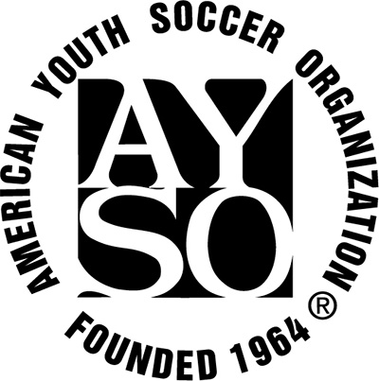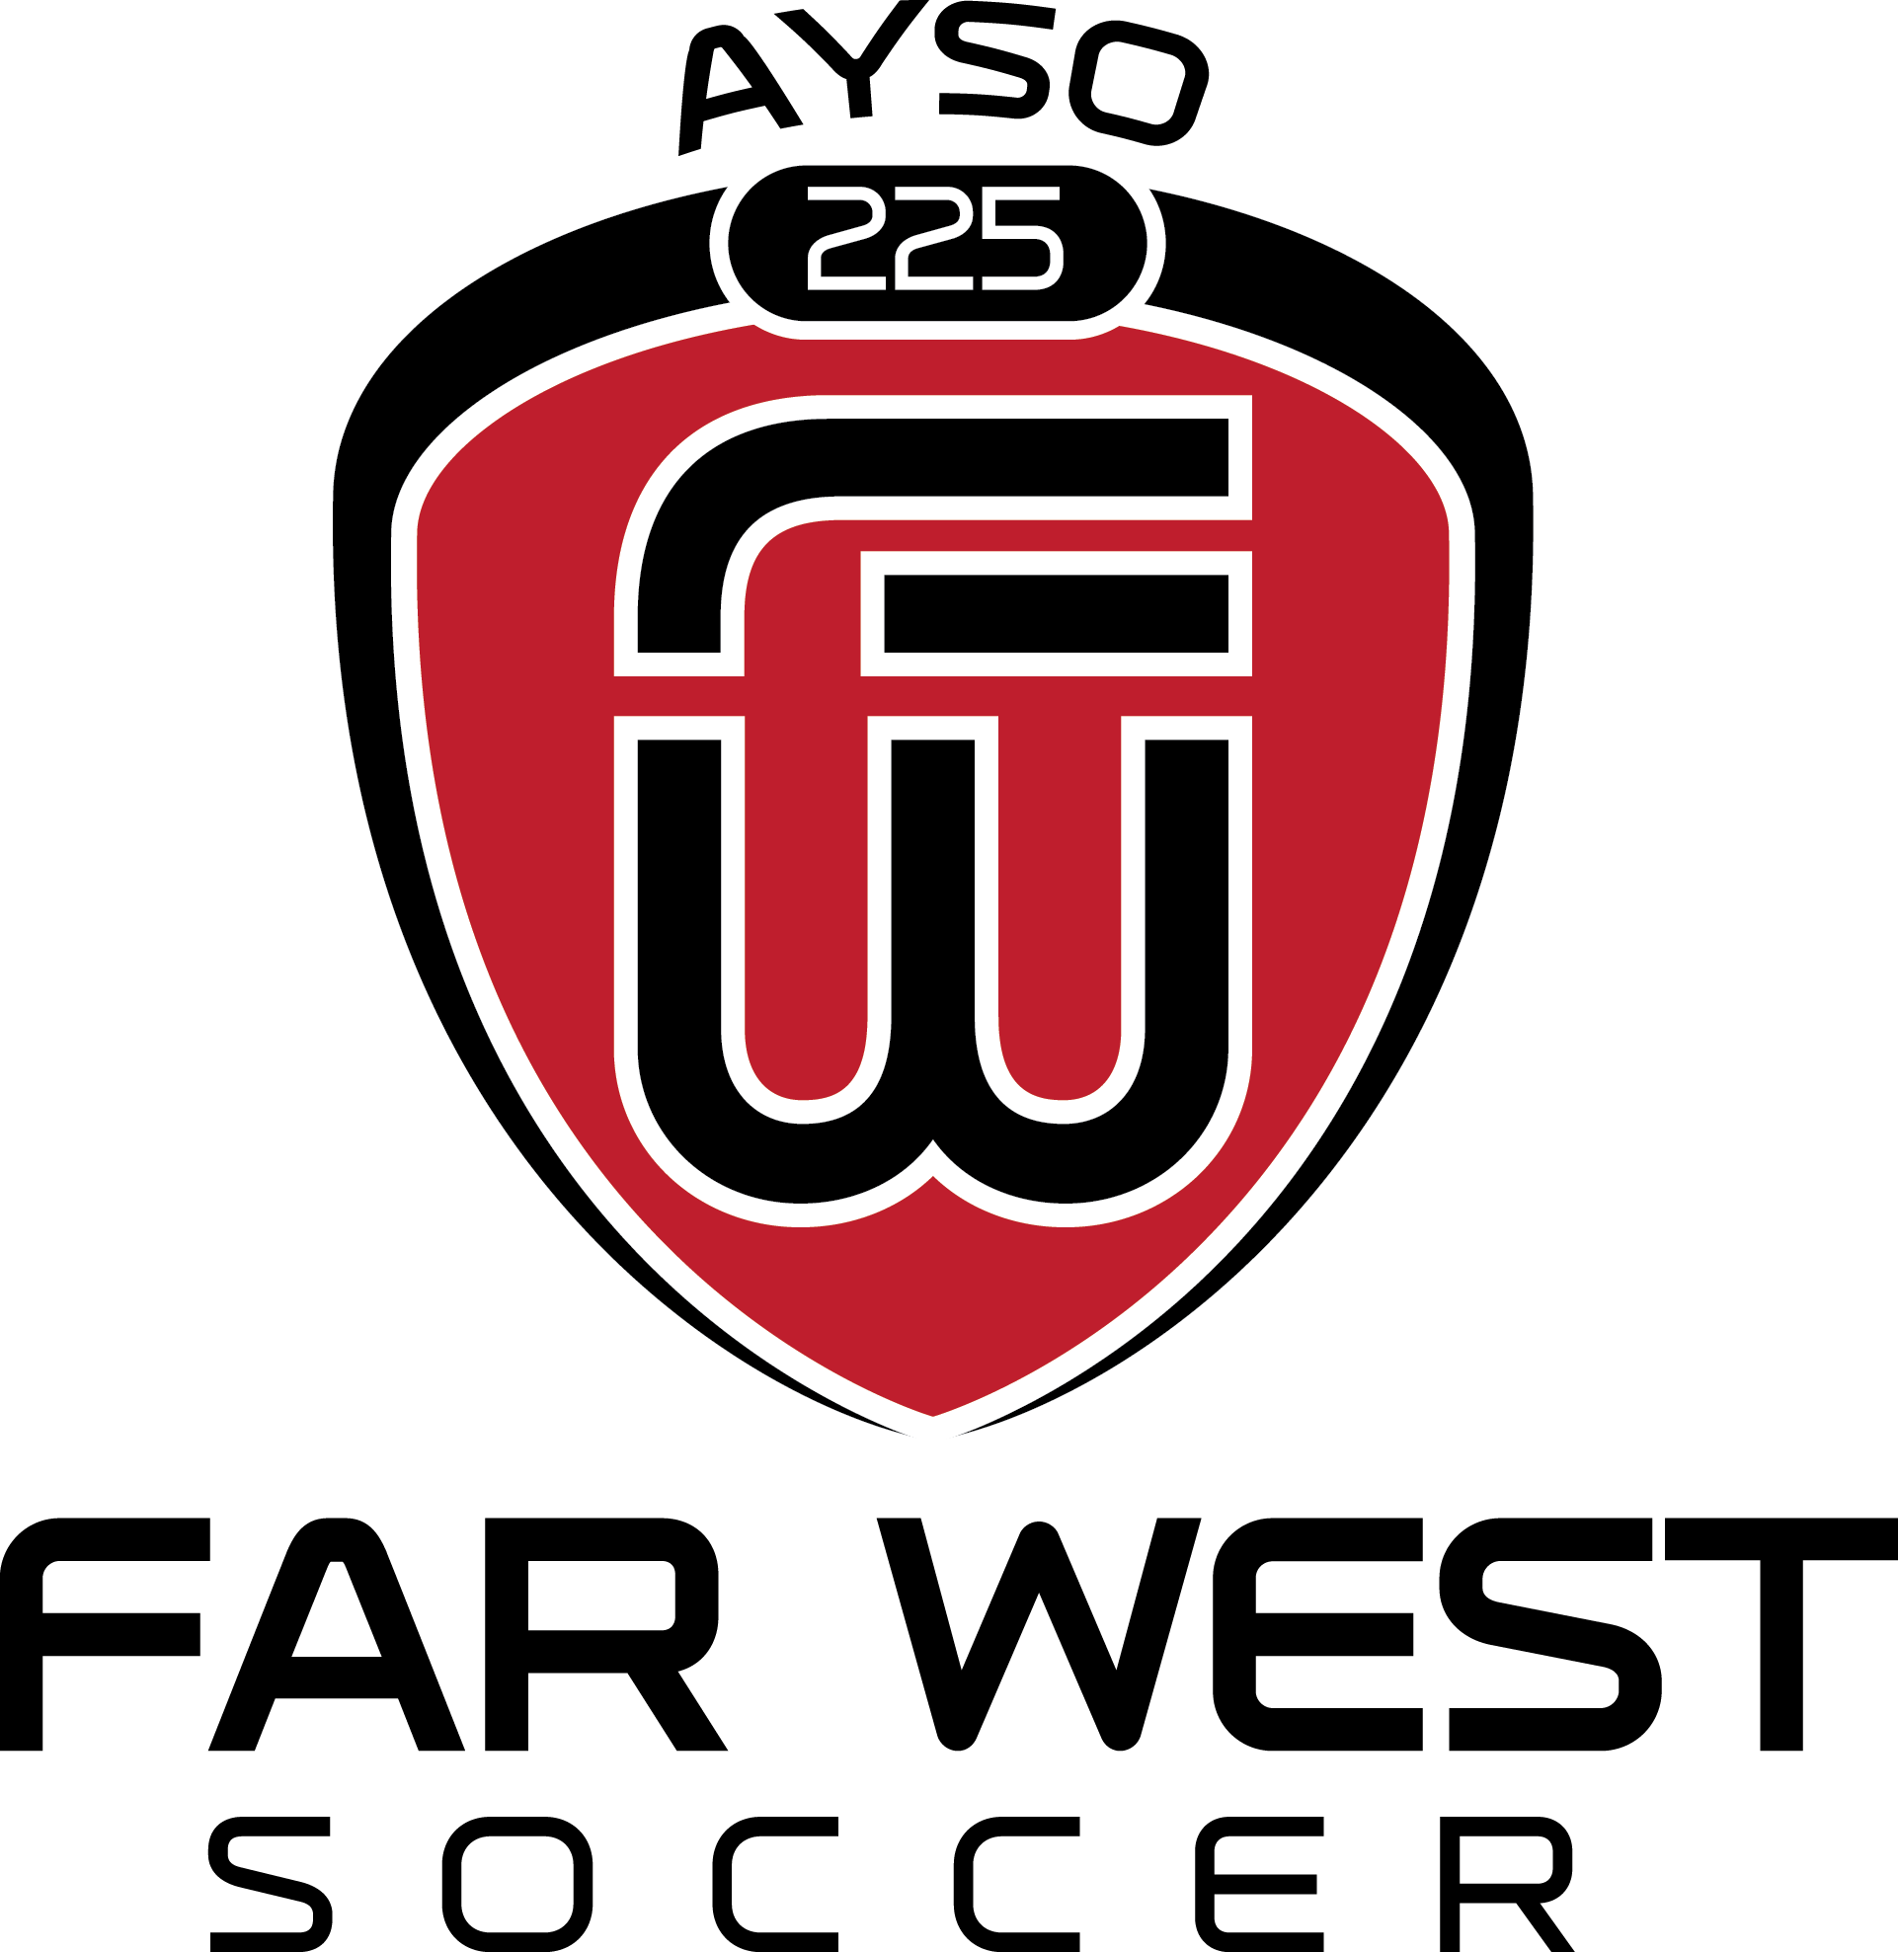

Mandatory Training

ALL staff volunteers in AYSO must participate in the following training curriculums:

- Safe Haven
- Concussion Awareness

In addition, coaches should have their coaching certifications:

- Age appropriate AYSO coaching certification
- F License with USSF

Training with AYSO is available at www.ayso225.org by selecting the tab “AYSOU”. The Safe Haven and Concussion Awareness class are free. The coaching certification does have a cost of $7. Once complete, we will reimburse you.

To obtain the “F” Licence with USSF, visit: https://dcc.ussoccer.com. The cost is $25 and will be reimbursed upon successful completion.

For reimbursement, please submit your receipt(s) to your appropriate Coach Administrator (Ray Gonzalez-GIRLS or Chris Barnes-BOYS). Contact information is available on our website under “About Us” – “Contact Us”.

Please notify your Coach Administrator once all classes have been complete. This is a necessary process by AYSO National standards with the exception of the “F” License. This is a proactive move on the part of our Region to assist in the future alignment with USSF regulations. Thank you for your compliance!

