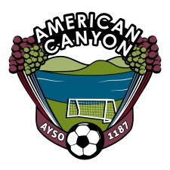
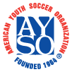
AYSO Board Meeting
January 17, 2012
5:30 PM – Mi Zacatecas - American Canyon

Board Members
Sam Link, Regional Commissioner  Cynthia Murphy, Treasurer  Rosa Zepeda, Purchaser  Mellissa Dugdale, CVPA  Melissa Diehl, Registrar  Stephanie Jones, Registrar  Fernando Flores, Coach Administrator  Kirk Conners, Coach Administrator  Derik Vides, Coach Administrator  Travis Behn, Coach Trainer | Bruce Jones, Referee Administrator  Robert Vega, Assistant Referee Administrator  Alisa Riddle, Assistant Referee Administrator  Duane Burnett, Assistant Referee Administrator  Al Frevle, Referee Trainer  Jose Narajo, Safety Director  Amanda Connaughton, Team Parent Coordinator
All Board Members please arrive ON TIME. We have a lot to review.
Topic Responsible Time
Opening Board 5:30
Treasury Report Murphy 5:33
- Outstanding AP
- Account Balance
- Checks
Volunteer Status Dugdale 5:40
- What is needed for Select?
- Volunteer Appreciation Gathering – Plans Vegas
Registrar Diehl/Jones 5:50
- Planning session for Registration 2013
Select Update Flores/Conners/Vides 6:00
Referee Update Jones/Vega/Burnett 6:10
- Winter Referees
Area 2/9 Conference All Board 6:15
- Who is going?
- What is reimbursed
- Tracks
Open Items
Volunteer Position for Raina Fox
Close 6:45

