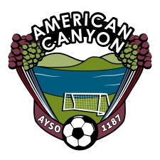
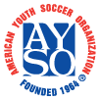
AYSO Board Meeting
November 8, 2012
6 PM – Mi Zacatecas - American Canyon

Board Members
Sam Link, Regional Commissioner  Cynthia Murphy, Treasurer  Rosa Zepeda, Purchaser  Mellissa Dugdale, CVPA  Melissa Diehl, Registrar  Fernando Flores, Coach Administrator  Kirk Conners, Coach Administrator  Travis Behn, Coach Trainer | Bruce Jones, Referee Administrator  Robert Vega, Assistant Referee Administrator  Alisa Riddle, Assistant Referee Administrator  Duane Burnett, Assistant Referee Administrator  Al Frevle, Referee Trainer  Iain Smith, Safety Director  Amanda Connaughton, Team Parent Coordinator
All Board Members please arrive ON TIME. We have a lot to review.
Topic Responsible Time
Opening Board 6:00
Introductions Link 6:03
- Derik Vides, Proposed Coach Administrator
- Jose Narajo, Proposed Safety Director
- Jon & Shannon Gamoras, Proposed CVPA
- Stephanie Jones, Proposed Registrar Assistant
Treasury Report Murphy 6:13
- Outstanding AP
- Account Balance
Safety Activities Smith 6:16
- Field preparation for Select
  - ACMS – Reserved NVUSD
  - Shenandoah – Reserved, not paid
  - Silver Oak – Reserved, not Paid
- Kimberly Shut Down
Volunteer Status Dugdale 6:22
- What is needed for Select?
- Volunteer Appreciation Gathering - Plans
Registrar Diehl 6:35
- 2C Tournament Rosters and Med Release forms
- Select Team Build
- 2013 Dates for registration
Coach Update Flores/Conners 6:40
- Tournament Coaches
- Select Coaches
Referee Update Jones/Vega/Burnett 6:48
- Winter Referees
Open Discussion All Board 6:55
- Prioritize Parking lot and items
- Easter AYSO Sponsorship
- 4th of July Parade and Fundraiser Activity?
Close 7:00

