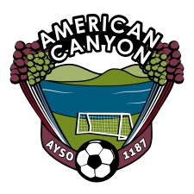
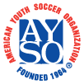
AYSO Board Meeting
September 26, 2012
7 PM – Mi Zacetecas - American Canyon

Board Members
Sam Link, Regional Commissioner  Gabriel Zepeda, Assistant Regional Commissioner  Cynthia Murphy, Treasurer  Mellissa Dugdale, CVPA  Melissa Diehl, Registrar  Fernando Flores, Coach Administrator  Kirk Conners, Coach Administrator | Travis Behn, Coach Trainer  Bruce Jones, Referee Administrator  Robert Vega, Assistant Referee Administrator  Al Frevle, Referee Trainer  Iain Smith, Safety Director  Amanda Connaughton, Team Parent Coordinator  Rosa Zepeda, Purchaser
All Board Members please arrive ON TIME. We have a lot to review.
Topic Responsible Time
Opening Board 7:00
Treasury Report Murphy 7:03
- Outstanding AP
- Account Balance
Outstanding Orders Rosa 7:05
- Trophies
Registered Players Diehl 7:15
- Refund Players
- Last Registered Total
Safety Activities Smith 7:18
- Field Inspection
- Field Marking
- Nets/Flags/Paint status
- Goal Staking
- Goal stencil warnings
Volunteer Status Dugdale 7:25
- Volunteers per team – Spreadsheet has holes
- Response from Coaches and Parents
- Compliance
- Risk to league
- Consequences for not providing volunteers
Coach Update Flores/Conners 7:40
Referee Update Jones/Vega/Burnett 7:48
Open Discussion All Board 7:55
- Prioritize Parking lot and items
Close 8:00

