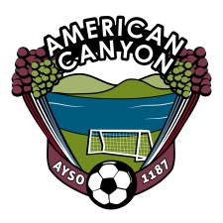
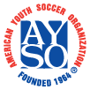
AYSO Board Meeting Minutes
September 4, 2013
6:30 PM – Mi Zacetecas - American Canyon

Board Members
Sam Link, Regional Commissioner  Cynthia Murphy, Treasurer  Melissa Diehl, Registrar  Fernando Flores, Coach Administrator  Kirk Connors, Coach Administrator  Derik Vides, Coach Administrator  Diego Ortiz, Elite (EXTRA) Coach Administrator  Travis Behn, Coach Trainer | Bruce Jones, Referee Administrator  Robert Vega, Assistant Referee Administrator  Alisa Riddle, Assistant Referee Administrator  Duane Burnett, Assistant Referee Administrator  Al Frevle, Referee Trainer  Jose Naranjo, Safety Director  Mellissa Dugdale, CVPA  Donell Mannor, Assistant CVPA
Board Member
Topic Responsible Time
Call to Order Board 6:30
Opening Day Murphy 6:35
- City Status
- Agenda
- Honored Guest’s
Coaching Update
- Challenger Training Schedule w/ Coaches Flores/Connors/Vides/Ortiz/Segura/Behn 6:45
- Uniform pickup – All teams have their uniforms?
Referee Update Jones/Vega/Burnett 6:55
- Referee Training
Volunteer Status Dugdale/ Mannor 7:00
- Who is still needing to certify?
Safety Issues Naranjo 7:05

Open Items Entire Board 7:10
Close 7:25

