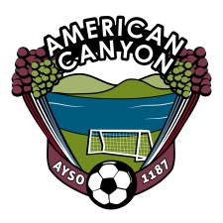
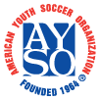
AYSO Board Meeting Minutes
July 31, 2013
7:30 PM – Mi Zacetecas - American Canyon

Board Members
Sam Link, Regional Commissioner  Cynthia Murphy, Treasurer  Melissa Diehl, Registrar  Stephanie Jones, Registrar/Fund Raising Chair  Fernando Flores, Coach Administrator  Kirk Connors, Coach Administrator  Derik Vides, Coach Administrator  Diego Ortiz, Elite (EXTRA) Coach Administrator  Travis Behn, Coach Trainer | Bruce Jones, Referee Administrator  Robert Vega, Assistant Referee Administrator  Alisa Riddle, Assistant Referee Administrator  Duane Burnett, Assistant Referee Administrator  Al Frevle, Referee Trainer  Jose Naranjo, Safety Director  Mellissa Dugdale, CVPA  Donell Mannor, Assistant CVPA
Board Member
Topic Responsible Time
Call to Order Board 7:30
Registrar Diehl 7:35
- Applicants not Registered
- Waiting List
Coaching Update
- Open Head Coach positions Flores/Connors/Vides/Ortiz/Segura/Behn 7:45
- Coaches Training – Challenger - Approved
- Coach Training Calendar
Referee Update Jones/Vega/Burnett 8:10
- Referee Training
Volunteer Status Dugdale/ Mannor 8:15
- What is needed to certify a volunteer BEFORE they begin their work?
Safety Issues Naranjo 8:20
- Goal repair
- Goal Painting/Labels
- Field Marking dates
Open Items Entire Board 8:35
- RAP REPORT
Close 8:45

