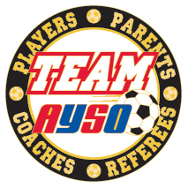
SAN MARCOS AYSO 127
TEAM INFORMATION SHEET
Please bring this sheet to the Team Parent Meeting. You will exchange this completed sheet for your team’s uniforms.
When: August 7th from 6:00PM-8:00PM
Where: San Marcos Community Center, 3 Civic Center Drive, San Marcos
(It is across the parking lot from the San Marcos Library).

Team’s Division: _________ Team’s Colors: _______________________________

Team Name: ________________________________________________________

Coach: ____________________________________________________________

Assistant Coach: _____________________________________________________

Team Parent: _______________________________________________________

Referee: ___________________________________________________________

Referee: ___________________________________________________________

