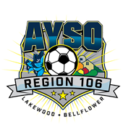 | Sponsored by AYSO Region 106 Lakewood-Bellflower, CA  21st Annual The Fox & The Hare  Soccer Tournament  PRE-ORDER T-SHIRT FORM | 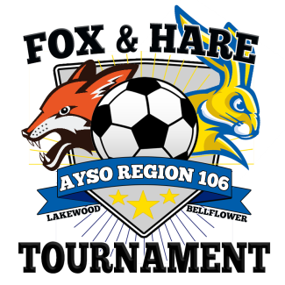

AYSO Region 106 would like to recognize the numerous volunteers who are dedicated to youth soccer by offering complimentary Tournament dri-fit shirts for the head coach, assistant coach, team parent, and 3 person referee crew (if providing).
Pre-order Tournament dri-fit shirts for players are available for $12 each.
A small inventory of dri-fit shirts will be available at the tournament for $15 each.

ALL TEAMS MUST USE THIS FORM TO PRE-ORDER YOUR VOLUNTEER/TEAM’S DRI-FIT SHIRTS.

REGION
TEAM NAME
HEAD COACH NAME
DIVISION
GENDER

Check YES or NO if your team is providing a REFEREE CREW for the tournament.
If YES, each referee (maximum of 3 referees) will receive a complimentary tournament dri-fit shirt.

SIZE |  | ADULT  S | ADULT M | ADULT  L | ADULT XL | ADULT 2XL
HEAD COACH | COMPLIMENTARY
ASSISTANT COACH | COMPLIMENTARY
TEAM PARENT | COMPLIMENTARY
REFEREE | COMPLIMENTARY
REFEREE | COMPLIMENTARY
REFEREE | COMPLIMENTARY

Please indicate in the box below the number of T-shirts per size and total cost.
SIZE | YOUTH  S | YOUTH  M | YOUTH  L | ADULT  S | ADULT M | ADULT  L | ADULT XL | ADULT 2XL | TOTAL # OF  T-SHIRTS | TOTAL  COST
PRE-ORDER
$12 each
PLEASE GO TO WWW.AYSO106.ORG FOR SHIRT SAMPLES
THIS FORM MUST BE RETURNED BY APRIL 28, 2017.
***Complimentary dri-fit shirts can only be guaranteed if pre-order form is submitted by deadline***
Email completed form to foxandhare@ayso106.org and/or mail form and payment to
Tournament Registrar Fox and the Hare Soccer Tournament P.O. Box 310 Lakewood, California 90714-0310.
Make checks payable to AYSO Region 106 (Personal checks accepted).

